ECOM SOLUTIONS – BROCHURE

*The Trusted Partner in Your E-Retail Journey*

**Aftermarket Logistics**

**Prompt Delivery & Cash Collection**

**Warehousing**

**Data Driven Insights**

*TCS offers a one-stop solution to all your E-Commerce needs that help you stay equipped with latest tools required for meeting the challenges of an ever-growing online market.*

Who We Are :

At TCS ECOM SOLUTIONS, we believe in providing a 360 degree platform to all our customers that not only caters to their existing needs but also provides them with insights backed by statistics for future opportunities and growth in the E-retail industry.

Being the leaders of logistics industry, our end-to-end ECom Solutions’ product offers services that are second to none and we take pride in being the pioneers for change through our dynamic portfolio that ensures smooth shipment preparation to seamless last mile deliveries.

Our Offerings:

* ENVIO PORTAL:   
  Our top of the line tool that makes your online selling journey easier than ever before. The Envio portal offers a one-window solution to all your needs that range from booking and tracking multiple shipments at once, creating cost centers in different cities to logging complaints and facilitating return logistics – all within the reach of a few clicks and without the hassle of having to go through exhaustive paperwork.   
    
  Key features include :
* **Multiple Users -** customers can now define and restrict different levels of access to different users, i.e., main user and sub user.
* **Multiple Accounts -** allow the users to control both general and overland shipment accounts from one channel
* **Order Reconciliation** - enables customer to cross check orders generated and booked to avoid any ambiguity.
* **Payment Details** – provide you with quick and complete details of the COD amount collected and shipment charges billed against a particular consignment
* **Complain/Service Request** – customers can make use of our portal to place their reservations against a particular shipment or to request a special service

* REVERSE LOGISTICS:

Returns will always be a part of business but we make sure you’re not limiting them to being a cost of business. An easy aftermarket logistics process can give you a competitive advantage that adds great value to your bottom line by improving customer satisfaction and ensuring customer loyalty to your business.

**Our Efficient Process Flow**

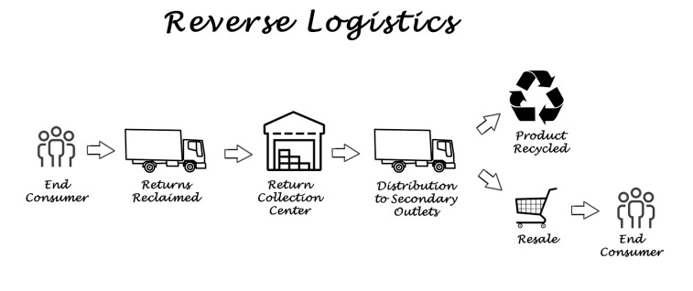  
  
  
The introduction of Reverse Logistics on our Envio portal has been a game changer that has allowed our customers to create return shipments which will be picked up from the Consignee and shipped back to them at a location of their choice.  
 Our return management solution feature enables you to improve customer satisfaction by meeting their high after-sales service expectations with a swift and easy process.

**Return Logistics Industry by Stats - Worldwide**

* SMART DE-BRIEFING:   
  Looking for a partner to get in touch with your customer on your behalf and comprehend the reasons behind incomplete deliveries? Look no further, you’ve been heard!   
  Our new-in ECom solution feature of smart de-briefing is designed to provide you with the understanding of why a particular order was not able to reach the customer and gives out necessary measures required to fulfil the missing element.

* Call Recording of conversation between our CSR and consignee
* Transparent information flow from the consignee to the customer via an audio file
* Insight into reasons behind unsuccessful delivery to avoid future problems
* MULTIPLE PICKUP & DELIVERY OPTIONS:   
  Book your shipments via our Envio portal and enjoy multiple pickup /delivery options where you have total control of all your locations from 1 account. Whether your business wants a daily pickup in case of high shipment volumes or you want speedy fast delivery to a destination, we have got you covered.

**First-Mile Services**

* Direct pickup from Vendors
* Pickups from multiple locations
* Drop shipments by Customer

* Automated/manual pickup request  
    
  **Last-Mile Services**
* Express Delivery (Sameday) – Premium service that ensures quick delivery using TCS aircrafts.
* Overland(OLE) – Cost friendly yet effective mode of delivery suitable for bulkier shipments
* Same Day Delivery – within city delivery within 24hours
* Detain Delivery – Cost friendly express delivery using our on-ground fleet

* TRACKING:   
  TCS ECOM Solutions believes the key to avoiding any misunderstandings is to keep both the involved parties in harmony with our process. An automatic email is generated to the customers that give out booking, delivery, and return details of shipments for cross verification. Meanwhile, on the other hand, consignees are kept in the loop both at the time of booking to the time of delivery of shipments. This adds to the customer experience which improves customer satisfaction.
* TCS E-tracking on google against consignment number on-the-go
* Detailed shipment status via Delivery Report on Envio portal
* Booking and pre-delivery Push notifications to consignees
* Prompt payments:
* **Customized Payment Plan** – based on how the online shoppers have opted to pay, either COD or prepayment, our tailor-made delivery design will be ready to match it.
* **Speedy Cash Transfer**

Cash flow management is an integral part of every successful business and we at TCS ECOM Solutions take every possible measure to facilitate you in this regard by transferring funds at regular intervals (monthly,weekly,48hours) using our express cash transfer mechanism. A complete payment summary along with billing reports can be accessed on our Envio portal from anywhere at any time as per requirement.

My Collect:   
With more than 970+ TCS Express Centers across the country, the consignees can now avail the “my collect” option in the Envio portal which allows them to pick up their shipments from the nearest Express Center at their convenience. Not only this, our wide range of Express Center network will assist the shipments that didn’t go through the first time due to unavailability of the consignee.

* Fulfillment Center:   
  Need to meet customer expectations across multiple channels for quick and timely deliveries while not having to worry about the warehousing and logistics?  
   TCS Ecom Solutions’ fulfilment models will do just that for you by eliminating your need of holding inventory or picking, packing and shipping orders using our top of the line warehousing and dispatching services.
* Shipper & Consignee Support:   
  Our Customer Support team is just a call away to provide every possible assistance on your shipments, payments and all other general queries so that you feel guided at every stage of your business.   
  Services :
* 24/7 customer service helpline
* FAQs on website
* Correspondence on emails and SMS